**Requirements elicitation and specification**

**(Project B)**

*by*

**Hyeokjin Kwon**

|  |  |  |  |
| --- | --- | --- | --- |
| Version Number | Date | Contributor | Description |
| Version 1 | 08.09.2021 | Hyeokjin Kwon | The First draft of the Requirements elicitation and specification |
| Version 2 | 11.09.2021 | Hyeokjin Kwon | The Second draft of the requirements elicitation and specification |
| Version 3 (Final) | 14.09.2021 | Hyeokjin Kwon | The final version of requirements elicitation and specification |

Table of Contents

Background/Summary …..……………………………………………………….…….………….…………… iii

* Project B................................................................................................................................................................... iii
* Project A................................................................................................................................................................... iii

Introduction of Project B SRS……………………………………………………….…….………………... iii-iv

* Document Overview............................................................................................................................................ iii-iv
* Release Overview..................................................................................................................................................... iv
* Environment............................................................................................................................................................. iv

Application Functional Requirements…………………………………………...…………..………..………. v-x

Application Quality Requirements...…………………………… ………………….………..……….…..… xi-xv

* NFR.................................................................................................................................................................... xi-xiv
* GUI Specifications.................................................................................................................................................. xv
* Security Requirements............................................................................................................................................. xv

Requirements Change Management...…………………………… …………………….………..…………… xvi

Use Case Diagram...…………………………… ………………….………..…………………………...…... xvii

Use Case Description...…………………………… ………………….………..………………….…… xviii-xxii

Interaction Diagram...…………………………… ………………….………..………...…………………… xxiii

Prioritisation Explanation...…………………………… ………………….……………………..……..…… xxiii

Requirement Elicitations that I used...…………………………… ………………….………..……..… xxiv-xxv

Evaluation of teammates ………………….………..………………………………………...............… xxiv-xxv

A plan for further requirements analysis………………….………..………………………………… xxvi-xxviii

Me as a client representative for Project A………………………………………….……………..……...… xxix

Log of interactions………………………………………………………..………..………..………………... xxx

Bibliography………………….………..…………………………………………………………..………… xxxi

# Background/Summary

## **project A**

Project A is now closely tied to the Sydney Metro system.

It aims to create a system that can detect potential slip hazards using current surveillance systems (such as security cameras), allocate staff and notify passengers.

I contributed to this project as a client representative.

## **project B**

Project B is closely related to the university server and several in-app systems(applications).

Project B’s system provides users with a combined calendar and access to multiple in-apps such as maps/GPS. The system can also access currently installed surveillance systems (such as security cameras) to keep track of how the busy food store is.

I contributed to this project as a system developer.

# Introduction of Project B SRS

## 

## **Document Overview**

I will call the system created through project B as MQExpert.

MQExpert is an interactive and extensive system that interacts with multiple systems and performs various features. Among the many features of MQExpert, the most important functional requirements can be divided into three.

1. MQExpert enables efficient plan management for users through interaction with university server and in-app calendar. (Details are described in the functional requirement)
2. MQExpert enables users to search for routes through interaction with GPS/MAP (details are described in the functional requirement).
3. MQExpert provides queue waiting time to users through interaction with the "How busy are they" system and security camera server (details are described in the functional requirement)

Also, there are many non-functional requirements that must be followed for a successful system. Among them, the non-functional requirements with the highest priority are as follows.

1. Correctness: The system probability of failure on demand (POFOD) should be low when the OneID user/ visitor search the shortest route and estimated arrival time for the destination
2. Development: When developing a system, proper modelling language and computer language should be used
3. Security: The system shall store the OneID user and the Food business accounts with a safe method

## **Release Overview**

|  |  |  |
| --- | --- | --- |
| **Release** | **Date Released** | **Version comments** |
| Version 1 | 08.09.2021 | The first draft of the requirements elicitation and specification |
| Version 2 | 11.09.2021 | The Second draft of the requirements elicitation and specification (some requirements are modified/deleted/added from V.1) |
| Version 3 | 14.09.2021 | The final version of requirements elicitation and specification (no other changes can be committed) |

## **Environment**

|  |  |
| --- | --- |
| **Operating system** | iOS and iPadOS 14.7.1. |
| Android 11 |
| **Database** | Oracle 9i, 10g |
| MySQL 8.0 |
| **Java** | 1.3.1 and above |
| **React native** | 0.65 and above |

# 

# Application Functional Requirements

## 

## **FR1. New user creation and login & default user**

### New Account registration

Requirements when Food businesses create a new account to use the MQExpert system

|  |  |  |
| --- | --- | --- |
| **R #** | **Req. Name** | **Requirement details** |
| 1.1 | Create account | The system shall allow Food business to create a new account |

### Logging into the System

Requirements when OneID user log in with their OneID

|  |  |  |
| --- | --- | --- |
| **R#** | **Req. Name** | **Requirement details** |
| 1.2 | Login with OneID | The system shall allow OneID users (Staff, Student) to log in with their existing OneID |
| 1.3 | Verify Account detail | The system shall verify users' account detail include roles(Staff, Student) through connection with the university server |
| 1.4 | Auto Login | The system shall allow automatic login and bypass the login prompt whenever OneID user start the system |

### Visitor mode

Requirement when a visitor ( who does not have OneID)uses the system

|  |  |  |
| --- | --- | --- |
| **R#** | **Req. Name** | **Requirement details** |
| 1.5 | Visitor mode | The system allows the Visitor mode to the user who did not log in with OneID |

## **FR2. User access**

### OneID user access

Requirements about which service OneID users can access

|  |  |  |
| --- | --- | --- |
| **R #** | **Req. Name** | **Requirement details** |
| 2.1 | OneID user access | The OneID user can access the In-app calendar, university timetable, academic schedule, GPS, Food business menu, and real-time queue |

### Visitor access

Requirements about which service Visitors can access

|  |  |  |
| --- | --- | --- |
| **R#** | **Req. Name** | **Requirement details** |
| 2.2 | Visitor access | The visitor can access the In-app calendar, GPS, Food business menu, and real-time queue |

### 

### Food service access

Requirements about which service Food services can access

|  |  |  |
| --- | --- | --- |
| **R#** | **Req. Name** | **Requirement details** |
| 2.3 | Food service access | The food service account can access the menu and queue manage |

## **FR3. View timetable and schedule**

### OneID user timetable and schedule

Timetable and schedule that OneID user can access

|  |  |  |
| --- | --- | --- |
| **R#** | **Req. Name** | **Requirement details** |
| 3.1 | View timetable | The OneID user can view the timetable from the university server |
| 3.2 | View university academic schedule | The OneID user can view the university academic schedule from the university server |
| 3.3 | View personal plan-OneID | The OneID user can view the personal plan from the in-app calendar |

### Visitor timetable and schedule

Timetable and schedule that the visitor can access

|  |  |  |
| --- | --- | --- |
| **R#** | **Req. Name** | **Requirement details** |
| 3.4 | View personal plan-visitor | The visitor can view the personal plan from the in-app calendar |

## **FR4. navigating**

### Navigating

Requirements about navigating

|  |  |  |
| --- | --- | --- |
| **R#** | **Req. Name** | **Requirement details** |
| 4.1 | Search route and time-OneID | The OneID user can search/view the shortest route and estimated arrival time for the destination |
| 4.2 | Search route and time-Visitor | The visitor can search/view the shortest route and estimated arrival time for the destination |
| 4.3 | Calculate route and time | The GPS/Map calculates the shortest route and estimated arrival time with given destination from the system shall and provide the result to the system shall |

## **FR5. Scan qr code**

### View menu-users

Requirements when OneID user/ visitor scan the QR code to view the menu list

|  |  |  |
| --- | --- | --- |
| **R#** | **Req. Name** | **Requirement details** |
| 5.1 | View Menu with scanning | The OneID user and visitor can choose “view menu list” from the system prompt after scanning the QR code from the store |
| 5.2 | View Menu-users | The system shall show the menu list when the user clicks “view menu list” |

### Check-in process

Requirements when OneID user/ visitor scan the QR code to check-in store

|  |  |  |
| --- | --- | --- |
| **R#** | **Req. Name** | **Requirement details** |
| 5.3 | Check-in with scanning | The OneID user and visitor can choose “check-in the store” from the system prompt after scanning the QR code from the store |
| 5.4 | Check-in process | The system shall send check-in data to the MyserviceNSW when the user clicks “check-in the store” |

## **FR6. Manage menu-Food business**

### View menu-Food business

Requirements when food business views the menu

|  |  |  |
| --- | --- | --- |
| **R#** | **Req. Name** | **Requirement details** |
| 6.1 | View Menu-Food business | The system shall allow the Food business to view their menu list for checking |

### Delete Menu

Requirements when food business deletes the menu

|  |  |  |
| --- | --- | --- |
| **R#** | **Req. Name** | **Requirement details** |
| 6.2 | Delete Menu | The system shall allow the Food business to delete the menu from their menu list |

### Create Menu

Requirements when food business creates the menu

|  |  |  |
| --- | --- | --- |
| **R#** | **Req. Name** | **Requirement details** |
| 6.3 | Create Menu | The system shall allow the Food business to create the new menu list |

### Update Menu

Requirements when food business updates the menu

|  |  |  |
| --- | --- | --- |
| **R#** | **Req. Name** | **Requirement details** |
| 6.4 | Update Menu | The system shall allow the Food business to update the menu from their menu list |

## **FR7. Queue management**

### View real-time queue

Requirements when different types of users are viewing the real-time queue

|  |  |  |
| --- | --- | --- |
| **R#** | **Req. Name** | **Requirement details** |
| 7.1 | View real-time queue-Food business | The system shall allow the Food business to view a real-time queue for checking |
| 7.2 | View real-time queue-OneID user | The system shall allow the OneID user to view a real-time queue for checking to decide which restaurant they should go |
| 7.3 | View real-time queue-Visitor | The system shall allow the visitor to view a real-time queue for checking to decide which restaurant they should go |

### Update real-time queue

Requirements when the real-time queue is updated

|  |  |  |
| --- | --- | --- |
| **R#** | **Req. Name** | **Requirement details** |
| 7.4 | Change the period setting | The Food business can change the period setting which is related to the term of retrieving new real-time queue data |
| 7.5 | Request real-time queue update | The Food business requests update of the real-time queue to the system every fixed period |
| 7.6 | Get video footage | The system shall get the video footage from the security camera server every fixed period |
| 7.7 | Calculate estimated waiting time | The system shall get the calculated estimated waiting time through the “How busy are they” system |
| 7.8 | Update real-time queue | The system shall change the real-time queue with calculated estimated waiting time from the “How busy are they” system |

## **FR8. notification**

### Notification

Requirements when the system sends a notification to the OneID user

|  |  |  |
| --- | --- | --- |
| **R #** | **Req. Name** | **Requirement details** |
| 8.1 | Send notification | The system shall allow the university server to send notifications about the university events and reminders of the class start to the OneID user |

# APPLICATION QUALITY (NON-functional) requirements

**Rank: High, medium, low by the priority**

NFR1. Availability

*Definition: The amount or percentage* *of time that the System is available for use by the users.* *Availabi**lity may be negatively impacted by a variety of events including, but not limited to, user error, hardware failure, external system events, unavailability of support personnel, etc.*

NFR1.1

Statement of Requirement:

The OneID user can use possible functions of the system for the given amount of time  
Fit Metric/Success Criteria:

The OneID user can use “Login with OneID”, “View timetable”, “View university academic time schedule”, “View personal plan”, “Search route and time”, “Scan QR code” for 24 hours everyday. However, The OneID user can not access to the “real-time queue” of the restaurant when the store is closed(non-opening hours or weekend)

Rank: Medium

NFR1.2

Statement of Requirement:

The visitor can use possible functions of the system for the given amount of time  
Fit Metric/Success Criteria:

The OneID user can use “View personal plan”, “Search route and time”, “Scan QR code” for 24 hours everyday. However, The visitor can not access to the “real-time queue” of the restaurant when the store is closed(non-opening hours or weekend)

Rank: Medium

NFR1.3

Statement of Requirement:

The Food business can use possible functions of the system for the given amount of time  
Fit Metric/Success Criteria:

The Food business can use “Create an account”, “Manage menu” for 24 hours everyday. However, The Food business can not access to the “Manage queue” when the store is closed(non-opening hours or weekend)

Rank: Medium

## 

NFR2. Compatibility

*Definition: The ability of the System under discussion to appropriately interact with others systems in its context.*

Statement of Requirement:

The system has high compatibility. Function well when other application are running or used with the different operating system. **Fit Metric/Success Criteria:**

The system shall allow the concurrent use with the other systems (“University server”, “In-app calendar”, “GPS/MAP”, “MyserviceNSW”, “How busy are they”, “Security camera server”)

The system shall allow the different OS (IOS, Andriod)

**Rank: Medium**

NFR3. Correctness

Definition: The allowable maximum number or percentage of errors of commission

Statement of Requirement:

The system probability of failure on demand (POFOD) should be low when the OneID user/ visitor search the shortest route and estimated arrival time for the destination

Fit Metric/Success Criteria:

The system probability of failure on demand (POFOD) should be less than 0.00002 (2 out of 100000 hits) when the OneID user/ visitor search the shortest route and estimated arrival time for the destination

Rank: High

NFR4. Installation Complexity

*Definition:* *The combination of direct or indirect costs of the installation of the System*

NFR4.1

Statement of Requirement:

The mobile version of the system can be installed with proper environment with the reasonable price **Fit Metric/Success Criteria:**

The mobile version of the system can be installed in android and ios devices for free

**Rank: Low**

**NFR4.2**

Statement of Requirement:

The installation of the mobile version of the system needs proper amount of device storage

**Fit Metric/Success Criteria:**

The installation of the mobile version of the system needs 500MB of device storage

**Rank: Medium**

NFR5. Scalability

*Definition: The ability of the System to fulfill its requirements for increasing numbers of users, transactions, etc*.

Statement of Requirement:

The system shall allow proper amount of concurrent user(CCU)  
Fit Metric/Success Criteria:

The system shall allow at least 5000 concurrent user(CCU)

**Rank: Medium**

**NFR6. Development:**

*Definition: The environment requirement when developing the system*

Statement of Requirement:

When developing a system, proper modelling language and computer language should be used  
Fit Metric/Success Criteria:

When developing a system, UML 2.x should be used as the modelling language, and Java, react native should be used as the development language

**Rank: High**

**NFR7. Responsiveness:**

**NFR7.1**

Statement of Requirement:

The system shall respond to view timetable and university academic plan from a OneID user within a reasonable time

Fit Metric/Success Criteria:

The system shall respond to view timetable and university academic plan from a OneID user within 90 seconds. If retrieving data is taking more than 90 seconds, retrieving timetable and university academic plan gets automatically canceled and sends a notification to the OneID user.

**Rank: Medium**

**NFR7.2**

Statement of Requirement:

The system shall respond to view personal plan from a OneID user and visitor within a reasonable time

Fit Metric/Success Criteria:

The system shall respond to view personal plans from a OneID user and visitor within 60 seconds. If retrieving data is taking more than 60 seconds, retrieving personal plan gets automatically canceled and sends a notification to the OneID user.

**Rank: Medium**

**NFR7.3**

Statement of Requirement:

The system shall respond to search route and time from a OneID user and visitor within a reasonable time

Fit Metric/Success Criteria:

The system shall respond to search route and time from a OneID user and visitor within 60 seconds. If retrieving data is taking more than 60 seconds, retrieving route and time gets automatically canceled and sends a notification to the OneID user

**Rank: Medium**

**NFR7.4**

Statement of Requirement:

The system shall respond to scan QR code within a reasonable time

Fit Metric/Success Criteria:

The system shall respond to scan QR codes within 80 seconds. If retrieving data is taking more than 80 seconds, retrieving the menu or check-in is canceled and sends a notification to the user

**Rank: Medium**

NFR8. Security

*Definition: The requirements of the System with respect to access control and/or other context-specific security rules and or regulations.*

Statement of Requirement:

The system shall store the OneID user and the Food business accounts with a safe method  
Fit Metric/Success Criteria:

The system shall hash the users’ account password through SHA-256 and salt it to store in the database

**Rank: High**

NFR9. Performance

*Definition: A measure of user expectations of System response times and storage cost*

NFR9.1

Statement of Requirement:

The notification of the event from the university server use a proper amount of memory  
Fit Metric/Success Criteria:

The notification of the event from the university server use only memory within 20KB

Rank: Low

NFR9.2

Statement of Requirement:

The system shall send a notification to the OneID user before starting the class **Fit Metric/Success Criteria:**

The system shall send a notification to the OneID user 10 minutes before the class start (error range $±$ 2 minutes)

**Rank: Low**

## **GUI Specifications**

The following is a list of unique GUI requirements to include the design, layout and usability.

|  |  |  |
| --- | --- | --- |
| **R#** | **Req. Name** | **Requirement details** |
| 1 | Name | The name of the system(MQExpert) should be on the top of the screen with bold, Hiragino Kaku Gothic Std, 36px. |
| 2 | Calendar | The personal calendar section should be under the system name and have one row of dates of the selected month. |
| 3 | Map | The map section should be under the calendar section and have a small map inside have the "search route" key under it. |
| 4 | Home Bar | The home bar should be placed on the bottom of the screen and should include 4 different buttons(home, search, queue, login) |

## **Security Requirements**

The following table contains the different kinds of user groups.

|  |  |
| --- | --- |
| **OneID User** | * Has privileges to access the university server with the OneID and password * Has privileges to access the in-app calendar * Has privileges to access the GPS/Map to search the route for the destination * Has privileges to access the camera to take the QR code * Has privileges to access the food business real-time queue * Has read only privilege to the in-app calendar and university schedule. |
| **Visitor** | * Is similar to OneID user but has less access to the system. * Has privileges to access the in-app calendar * Has privileges to access the GPS/Map to search the route for the destination * Has privileges to access the camera to take the QR code * Has privileges to access the food business real-time queue * Has read only privilege to the in-app calendar. |
| **Food Business** | * Anyone managing food businesses on campus * Has limited access to the system * Can create an account * Has privileges to manage the menu list * Has privileges to manage the queue * Has privileges to update real-time period |

# Requirement Change Management

The following is the change configuration log for this document:

|  |  |  |  |  |  |
| --- | --- | --- | --- | --- | --- |
| **Date** | **Submitted By** | **Change type** | **Change ID** | **Change Details** | **Status** |
| 27/08/2021 | Hyeokjin Kwon | Creation | RCM_1 | FR1.5, 2.2, 3.3, 3.4, 4.2, 7.3 were created since a new type of user is added(visitor) | Approved |
| 28/08/2021 | Hyeokjin Kwon | Modification | RCM_2 | FR 5.1, 5.3 were modified since a new type of user is added(visitor) | Approved |
| 07/09/2021 | Hyeokjin Kwon | Deletion | RCM_3 | Some non-feasible requirements were deleted after the “feasibility of specification” meeting on 04/09/2021 (e.g. the real-time top-down list by selling amount for food businesses) | Approved |
| 10/09/2021 | Hyeokjin Kwon | Creation | RCM_4 | NFR5 was created since the scalability need to be specified | Approved |
| 10/09/2021 | Hyeokjin Kwon | Creation | RCM_5 | FR8 was created since the client representative wanted to add a notification function to the system | Approved |
| 13/09/2021 | Hyeokjin Kwon | Modification | RCM_6 | NFR5 was modified from 500 concurrent users to 5000 concurrent users considering the university students population | Approved |
| 13/09/2021 | Hyeokjin Kwon | Creation | RCM_7 | NFR7.4 was created since the response time of the QR scanning was not specified | Approved |

# Use Case Diagram

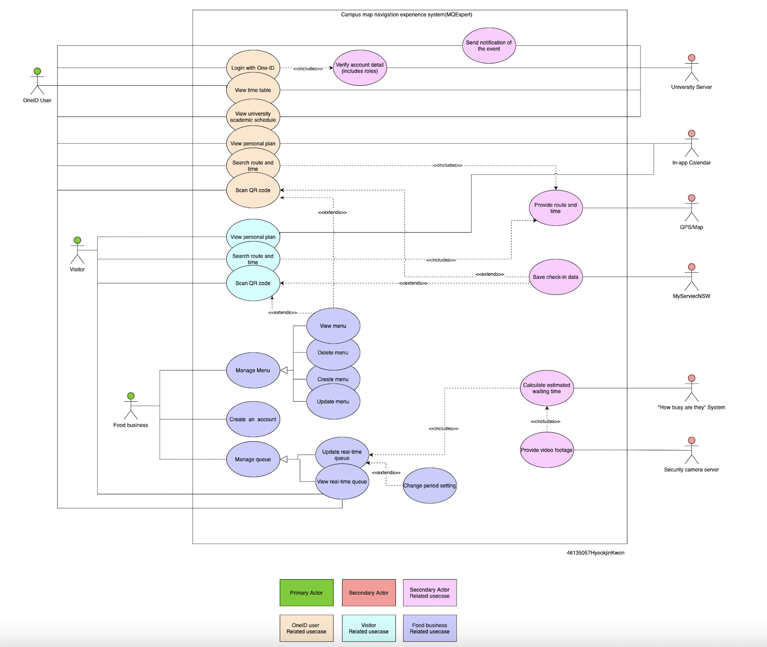

# Use Case Description

**System name: MQExpert**

|  |  |  |
| --- | --- | --- |
| **Use Case** | View university academic schedule | |
| **Goal** | To check university academic schedule | |
| **Preconditions** | The OneID user has already completed login and verification | |
| **Success End Condition** | MQExpert displays the university academic schedule | |
| **Failed End Condition** | University academic schedule is not displayed | |
| **Primary Actors;**  **Secondary Actors** | OneID user  University Server | |
| **Trigger** | The OneID user wants access to university academic schedule | |
| **Description / Main Success Scenario** | **Step** | **Action** |
| 1 | MQExpert provides the OneID user the option to view university academic schedule |
| 2 | The OneID user selects the ‘View university academic schedule’ option |
| 3 | The OneID user selects the type of academic schedule they want to retrieve (‘Staff’’/ ‘Student’) |
| 4 | MQExpert sends a request to access the university schedule to the university server |
| 5 | The university server checks the identification and role of the OneID user and grant access to the academic schedule |
| 6 | MQExpert displays the university academic schedule to the OneID user |
| **Alternative Flows** | **Step** | **Branching Action** |
| 3.a | The OneID user selects the ‘Staff’ |
| 3.a1 | MQExpert sends a request to access the university schedule for ‘Staff’ |
| 3.b | The OneID user selects the ‘Student’ |
| 3.b1 | MQExpert sends a request to access the university schedule for ‘Student’ |
| 4.a | The connection between MQExpert and the university server is unstable |
| 4.a1 | MQExpert displays an error message and prompts the OneID user to check the connection |
| 4.a2 | Go back to step1 |
| 5.a | The OneID user’s identification is expired |
| 5.a1 | MQExpert displays an error message and prompts the OneID user to login again to verify the account |
| 5.b | The OneID user can’t access to the given type of academic schedule (‘Staff’, ‘Student’) |
| 5.b1 | MQExpert displays an error message |
| 5.b2 | Go back to step3 |
| 6.a | The connection between MQExpert and the university server is unstable |
| 6.a1 | MQExpert displays an error message and prompts the OneID user to check the connection |
| 6.a2 | Go back to step1 |

|  |  |  |
| --- | --- | --- |
| **Use Case** | Search route and time | |
| **Goal** | To get the shortest route and estimated arrival time | |
| **Preconditions** | MQExpert has access to user device GPS | |
| **Success End Condition** | MQExpert displays the shortest route and estimated arrival time for the given destination | |
| **Failed End Condition** | The shortest route and estimated arrival time for the given destination are not displayed | |
| **Primary Actors;**  **Secondary Actors** | OneID user/ Visitor  GPS | |
| **Trigger** | The OneID user/ Visitor wants to search the route and time for destination | |
| **Description / Main Success Scenario** | **Step** | **Action** |
| 1 | MQExpert prompts the OneID user/ Visitor to enter the destination |
| 2 | The OneID user/ Visitor enters the destination and press ‘directions’ |
| 3 | MQExpert transfers given information to the GPS/Map system |
| 4 | The GPS/ Map system calculates and sends the shortest route and estimated arrival time to MQExpert |
| 5 | MQExpert displays the shortest route and estimated arrival time to OneID user/ Visitor |
| **Alternative Flows** | **Step** | **Branching Action** |
| 2.a | The OneID user/ Visitor enters an invalid destination (non-existent location) |
| 2.a1 | MQExpert displays an error message and prompts the user to enter new destination |
| 2.a2 | Go back to step2 |
| 3.a | The connection between MQExpert and the GPS/ Map system is unstable |
| 3.a1 | MQExpert displays an error message and prompts the user to check the connection |
| 3.a2 | Go back to step1 |

|  |  |  |
| --- | --- | --- |
| **Use Case** | Update real-time queue | |
| **Goal** | To update real-time queue | |
| **Preconditions** | MQExpert has access to Security camera server and “How busy are they” system | |
| **Success End Condition** | MQExpert updates real-time queue for Food business | |
| **Failed End Condition** | Real-time queue for Food business is not updated | |
| **Primary Actors;**  **Secondary Actors** | Food business  Security camera server, “How busy are they” system | |
| **Trigger** | Food business wants to update real-time queue periodically | |
| **Description / Main Success Scenario** | **Step** | **Action** |
| 1 | Food business requests update of real-time queue to MQExpert |
| 2 | MQExpert requests a new “queue waiting time” to “How busy are they” system |
| 3 | “How busy are they” system requests new video footage to the security camera server |
| 4 | Security camera server provides video footage of food and retail outlet to “How busy are they” system |
| 5 | “How busy are they” system calculates estimated waiting time using given video footage |
| 6 | “How busy are they” system sends a calculated waiting time to MQExpert |
| 7 | MQExpert updates food business’ queue information |
| **Alternative Flows** | **Step** | **Branching Action** |
| 2.a | The connection between MQExpert and the “How busy are they” system is unstable |
| 2.a1 | MQExpert displays an error message and prompts the user to check the connection |
| 2.a2 | Go back to step1 |
| 5.a | The calculated value from the “How busy are they” system is invalid, e.g.) estimated waiting time: -30 minutes |
| 5.a1 | Check the algorithm of the “How busy are they” system |
| 6.a | The connection between MQExpert and the “How busy are they” system is unstable |
| 6.a1 | MQExpert displays an error message and prompts the user to check the connection |
| 6.a2 | Go back to step1 |

# Interaction Diagram

# Prioritisation explanation

First can select the three most important requirements, reflecting the functional requirements of MQExpert and the opinions of client representatives. The three are "View university academic schedule", "Search route and time", and "Update real-time queue". All three of these are the functions that the client considers most important and these are relatively more complicated than other functions and are closely connected with the secondary actor. "View university academic schedule" is important because it can be executed when OneID is successfully linked to the university server. "Search route and time" is important because it must be able to successfully access the user's phone's GPS/MAP to send and retrieve data.

There are three reasons why "Update real-time queue" is the most important:

1.Other functions are easily found in many applications, but this function was developed exclusively for this application.

2. This function is a very complex function that applies complicated technologies like augmented reality.

3. The client was an expert on the security system, and in the user specification and subsequent meetings, the client representative said this is the function they valued the most.

# Requirement elicitations that I used

Interview and survey were used to elicit the requirements.

Since MQExpert is a new system that combines various functions, it is difficult to find a system with exactly the same function. Therefore, after having a client representative use an application with similar features called "Lost Campus(Figure.1)" got feedback on it to find out what to improve and what requirements MQExpert needs.

Fig.1) Lost Campus

1. Survey

The survey was used to figure out which functions the client representative considered useful. Functions with high satisfaction by the client representative will be implemented similarly, and functions with low satisfaction will be deleted or be improved.

In Questionnaires, all functions’ importance is measured in interval scales. Therefore, the developer can promptly identify the functions that the client considers necessary or relatively insignificant. As shown in Table 1 and Table 2, It is possible to change how the system should be implemented before starting development by identifying clients’ needs.

Table 1) Example of the questionnaires used for requirement elicitation

|  |  |  |  |  |  |
| --- | --- | --- | --- | --- | --- |
| “How efficient is it to find the route for the destination by clicking the site on the map?” | | | | | |
| Not Useful At All | | | Extremely Useful | | |
| 1 | 2 | 3 | | 4 | 5 |

Table 2) Example of the questionnaires used for requirement elicitation

|  |  |  |  |  |  |
| --- | --- | --- | --- | --- | --- |
| “How efficient is it to click the Restaurant on the map to see closing hours and additional information?” | | | | | |
| Not Useful At All | | | Extremely Useful | | |
| 1 | 2 | 3 | | 4 | 5 |

1. Interview

The interview was used to figure out which new functions the client representative considered needed. For a successful interview, I conducted a structured interview with predefined open-ended questions. Furthermore, I asked additional questions when I can't understand what the client representative need.

Table 3-5 is the examples of the questions used for the interview.

Table 3)

|  |
| --- |
| “Do you think QR code is convenient? If you think so, what functions could be used with QR code scanning” |
| Client representative’s answer |

Table 4)

|  |
| --- |
| “How many user types do you want to have in the system?” |
| Client representative’s answer |

Table 5)

|  |
| --- |
| “What additional features do you want to have in the system?” |
| Client representative’s answer |

# Evaluation of teammates

What I liked the most about the client representative was that she kept asking for creative features that I cannot think of. This means she has done a lot of researches and thinking. For example, one of the requirements that she wanted was really creative and cannot be found in the assignment specification. That was the notification from the university server to the system to let the user know they have a class within 10 mins. Furthermore, she always tried to get her work done on time and was a really good communicator. Since I am not born in Australia when I have some problems in understanding syntaxes or her intention she always tries to rephrase and take it slow again for better communication and teamwork.

However, her worst part was that she is too creative sometimes. Some of her requirements were unrealistic, hard to implement, too complicate, off-topic, or costly, which are tough jobs for the development team. For example, she wanted the system to have a feature that sorts each restaurant's order as the real-time top-down list by selling amount. However, I(developer) thought that is not the essential function for customers and the system. Furthermore, that feature is tough to implement and unrealistic since the food business needs to communicate with the order database in real-time. The problem is that the system does not contain an order system and database to track and store the order data.

# A plan for further requirements analysis

While continuing developing, the JAD method and prototyping can be used for further requirement elicitation.

The JAD involves clients in the system development stage. JAD does not interview clients one by one but gathers clients together and holds meetings similar to brainstorming to identify new feature ideas and existing problems. Through the JAD process, developers can analyze whether the developing process is on the right track [1]. JAD can shorten development time and increase end-user satisfaction.

A prototype is a new type of machine or device that has not yet been built and sold [1]. While eliciting requirements through the JAD, the client can have a better understanding of the system by reviewing the prototype.

For example, when iterating prototype development/modification/supplementation, multiple JAD conferences can be held to identify problems with the prototype and add new features.

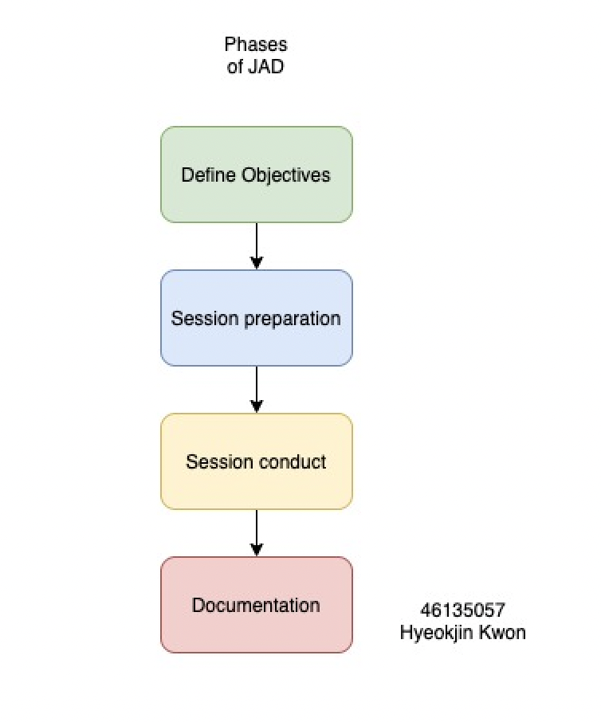

Fig.2) Phases of JAD Source) Adopted from [2]

As shown in Figure 2, the developer or JAD manager can conduct the session( discussion/ Brainstorming) when they have the new prototype to test. Depending on their purpose and function, there are different types of prototypes used as references in JAD. Based on completeness, prototypes can be divided into low-fidelity and high-fidelity [3].

Low-fidelity refers to a paper model that shows low-quality and rough designs and functions, and high-fidelity refers to a high-quality prototype that can show links between pages when clicked the button.

Figure 3 depicts the example of the UI prototype of the MQExpert system. UI prototypes can be created to help customers understand how the system works.

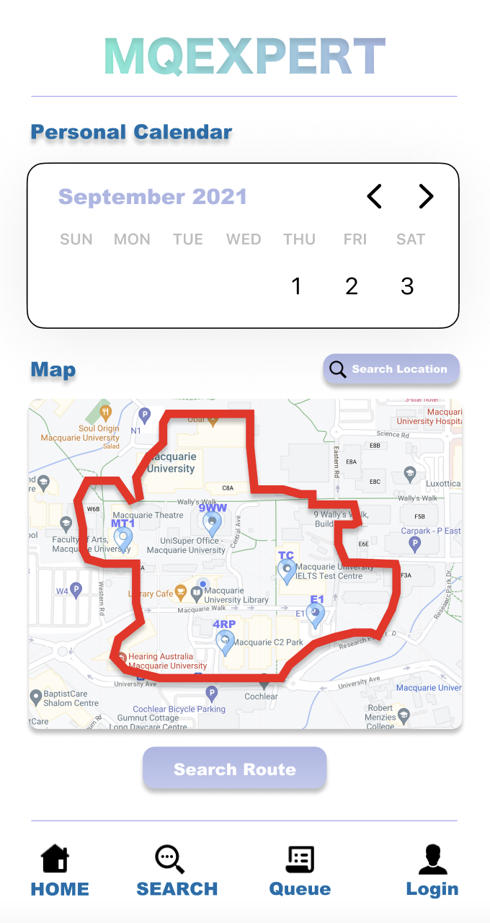

Fig.3) Example of High-Fidelity UI Prototype of MQExpert system made with Figma

Through this Figure 3 UI prototype, clients can check whether the developer understands their requirements properly and designs the system. Furthermore, developers can add functions or change the UI through feedback from clients to adjust the specific feature of the product. In conclusion, through prototype and JAD, insufficient requirements can be supplemented, modified, and deleted.

# Me as a client representative for project A

Before the first session(discussion) meeting, I tried to investigate the existing system(Transport NSW) thoroughly. I thought that convenience and safety are the keys to increase user satisfaction with the system, hence I considered deeply which features users really want and propose them to the developer as a client representative. For example, the requirement of the system to classify incident categories from high to low according to the degree of risk provides users with more information about the incident and reduces the probability of exposure to risk. In addition, the requirement to enter into the system whether the staff has completed the First Aid/CPR training is directly related to the arrangement and work of the staff, and this ultimately affects the safety, convenience, and impact of customers. In other words, since the system is related to safety, the requirements that I was most focused on were convenience and the factors indirectly related to the safety of customers.

Furthermore, I was always willing to share ideas when they came up, plan and schedule projects, and lead. I thought that a good client representative would have to irritate the developer and give inspiration, for that reason I gave the developer the right amount of idea and pressure to come up with better systems and features.

However, not everything went effortlessly as planned. The main reason for that is because of the covid-19 circumstances. Since we are not allowed to meet and discuss in person, we had to use a single platform (zoom) to communicate online, which derives a limitation of the resources. In addition, this weakening of human interaction sometimes caused communication failure between client and developer, which resulted in unnecessary time cost.

# Log of interactions

|  |  |  |  |  |
| --- | --- | --- | --- | --- |
| DATE | TIME | DURATION | TOPIC | MAIN DECISIONS |
| 24 Aug 2021 | 6:51 PM | - | Project Choice | Finalised which project we want to do |
| 25 Aug 2021 | 8:00 PM | 30 minutes | General Discussion about A1 | Prepare a list of requirements/wants for each project by tomorrow (26th) |
| 26 Aug 2021 | 8:00 PM | 1 hour and 5 minutes | Client Meeting | Agreed upon requirements  Discussed SRS structure/document |
| 4 Sep 2021 | 7:02 PM | 30 minutes | Feasibility of Specification | Discussion about the feasibility of the given specification by the client representative |
| 8 Sep 2021 | 2:08 PM | 20 minutes | SRS Draft | Share(show) the 1st draft(version) of the SRS to the client representative |
| 9 September | 6:00 PM | 30 Minutes | Reflection | Confirmation of elicitation methods and ensured that we were happy with each other (newly-added)  requirements |
| 11 September | 6:00 PM | 40 Minutes | SRS Version 2 | Share(show) the 2nd draft(version) of the SRS to the client representative |
| 12 September | 5:30 PM | 30 Minutes | Reflection | Share opinions for modified, deleted or created requirements |
| 14 September | 3:10 PM | 60 Minutes | Final Version | Share(show) the final version of the SRS to the client representative |

# Bibliography

|  |  |
| --- | --- |
| [1] | D. S. J Wood, Joint application development, New York: John Wiley & Sons, 1995. |
| [2] | Study.com, [Online]. Available: https://study.com/academy/lesson/joint-application-development-definition-phases-methodology.html. [Accessed 04 09 2021]. |
| [3] | James R Rudd,Ken Stern,Scott Isensee, "Low vs. high-fidelity prototyping debate," *Low vs. high-fidelity prototyping debate,* vol. 3, no. 1, p. 76–85, 1996. |